

Practices for Secure Software Report

Document Revision History

Version | Date | Author | Comments
1.0 | 04-19-2025 | Brandon Canady

Client



Instructions

Submit this completed practices for secure software report. Replace the bracketed text with the relevant information. You must document your process for writing secure communications and refactoring code that complies with software security testing protocols.

- Respond to the steps outlined below and include your findings.
- Respond using your own words. You may also choose to include images or supporting materials. If you include them, make certain to insert them in all the relevant locations in the document.
- Refer to the Project Two Guidelines and Rubric for more detailed instructions about each section of the template.

Developer
Brandon Canady

- Algorithm Cipher

The primary objective of Artemis Financial is to offer financial programs to clients worldwide. With this in mind, I recommend using SHA-256 as the encryption algorithm cipher. This cipher ensures that sensitive information is protected from unauthorized access. Recognized as one of the most secure hashing algorithms available, SHA-256 is practically impossible to crack through brute-force methods—it would take years of continuous attempts to break it.

SHA-256 is widely recommended when communicating with financial institutions due to its reliability and strength. The algorithm relies on bit-level encoding and randomness, which play key roles in ensuring unpredictability and security. When generating a hash, the input value is first compressed to produce a fixed-size output known as the hash value. For SHA-256, this results in a 256-bit output. The number of possible combinations offered by 256-bit encryption makes unauthorized access extremely difficult.

Random number generation enhances this security by introducing unpredictability, which further strengthens the algorithm against attacks. Symmetric encryption, which uses a single shared key for both encryption and decryption, is one of the most basic and efficient forms of encryption. A key advantage of symmetric keys is that they are faster and require fewer computational resources (Yedakula, K., 2019). AES-256, for instance, is a symmetric encryption method that pairs well with SHA-256 for securing plaintext data.

On the other hand, asymmetric encryption involves the use of two keys—public and private—and is considered more secure for internet communication due to the separation of encryption and decryption processes.

The history of encryption dates back to around 600 BC (Thales Group, 2016). Over time, encryption techniques have evolved to meet growing demands for data protection. As technology progresses, the importance of safeguarding information remains a constant priority for individuals and organizations alike.

- Certificate Generation
Insert a screenshot below of the CER file.

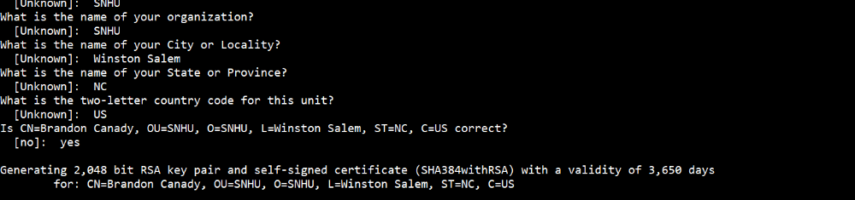
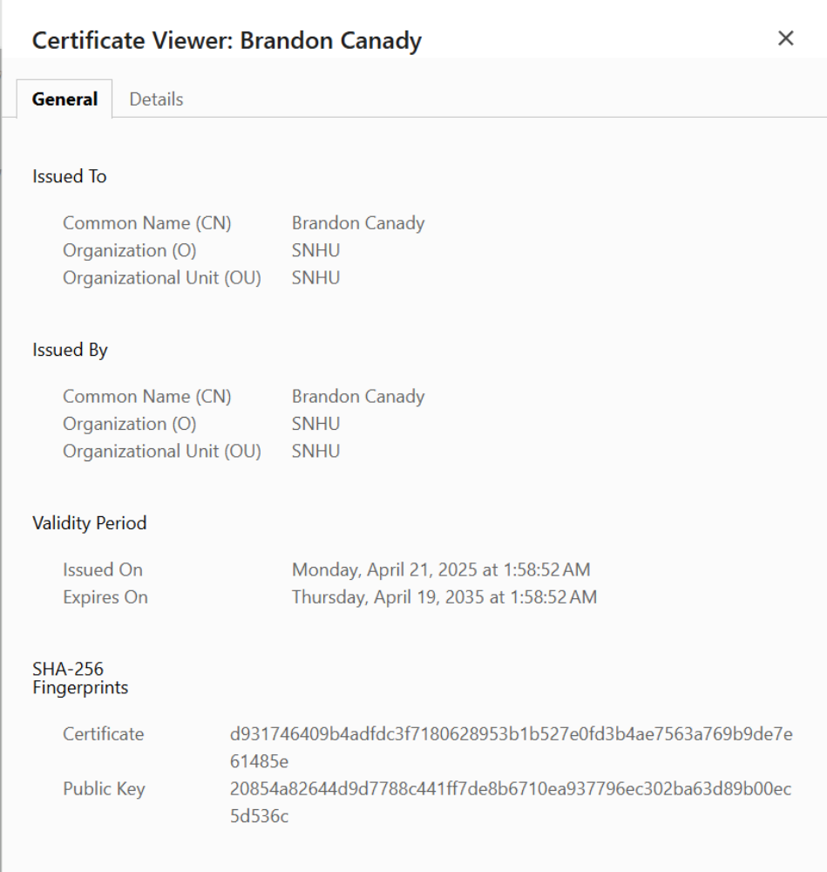

- Deploy Cipher
Insert a screenshot below of the checksum verification.

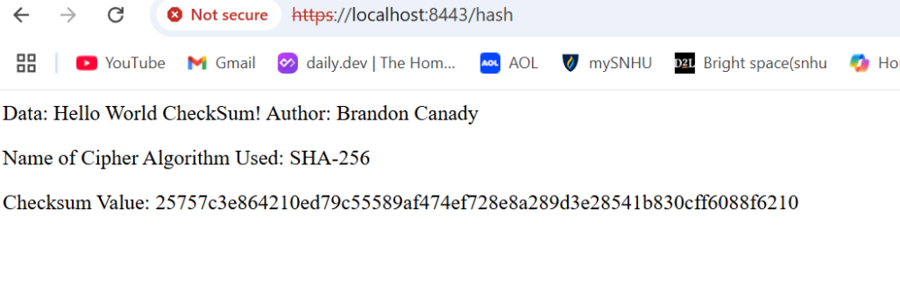

- Secure Communications
Insert a screenshot below of the web browser that shows a secure webpage.
I've observed that the self-signed certificate is flagged as invalid. However, I'm still able to access the siteusing the HTTPS protocol and view the certificate information.
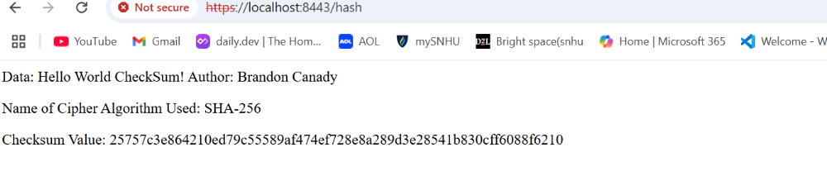

- Secondary Testing
Insert screenshots below of the refactored code executed without errors and the dependency-check report.

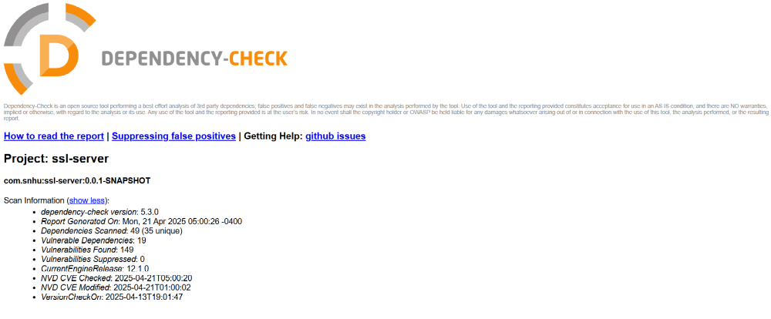

- Functional Testing
Insert a screenshot below of the refactored code executed without errors.
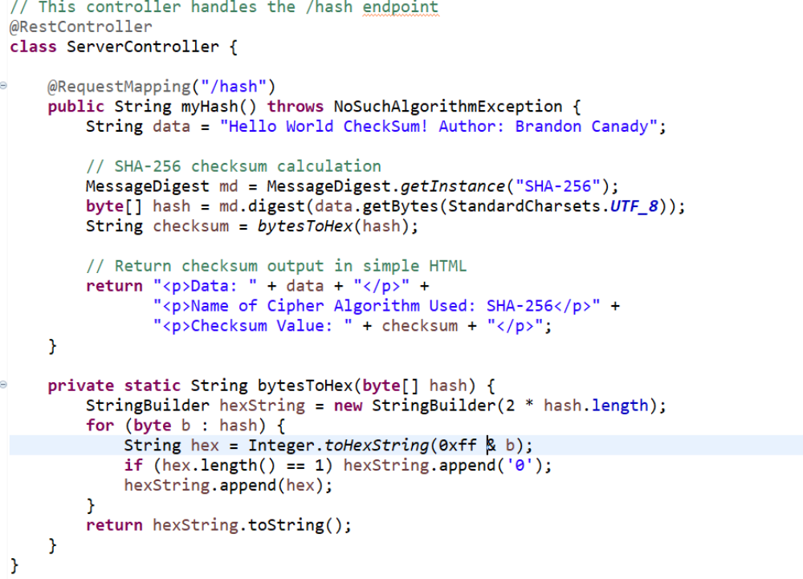

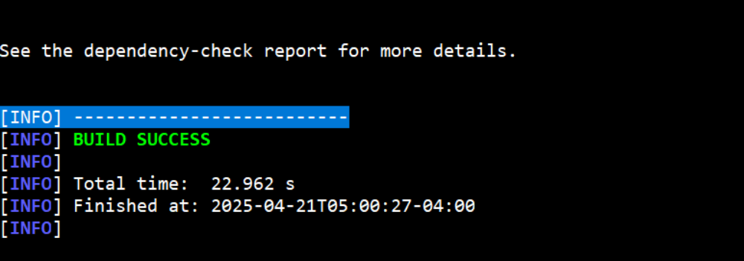

- Summary

One of the key tasks in refactoring the code was implementing cryptographic functions to enhance information security and prevent unauthorized access to the application. By introducing the SHA-256 hashing function (implemented in line 64 of SslServerApplication.java), the application demonstrates how potentially sensitive user input can be securely processed. This addresses the Cryptography aspect of the Vulnerability Assessment and Protection Framework (VAPF) and also contributes to Input Validation by ensuring only expected and manageable input is handled by the system.

Additionally, by generating and managing SSL certificates and updating the application.properties file, the project addresses the Client/Server Communication component of the VAPF. Establishing a secure HTTPS connection ensures that only authorized users can access specific parts of the application, reducing exposure to threats that exist over unsecured HTTP connections.

- Industry Standard Best Practices

Thorough testing played a critical role in the development process, with several roadblocks providing valuable insight that helped guide the successful completion of the project. The use of the OWASP Dependency Check tool was instrumental in identifying any new vulnerabilities introduced during refactoring, signaling when additional code changes were necessary. Code reviews were also conducted, which not only enhanced security but led to noticeable improvements in application performance.

Consistent testing, validation, and review are essential practices in any software development lifecycle. These practices allow errors to be caught early, enabling faster and more effective resolution. When developing an application for a financial organization like Artemis Financial, overlooking secure coding practices could result in serious financial and reputational damage. Taking the time to build secure, reliable code is not just best practice—it is a critical responsibility.

